National University of Computer and Emerging Sciences



Lab Manual 7
SE3003 – Web Engineering

Course Instructor | Sir Mudassir Saeed
Lab Instructor(s) | Marwa Khan
Section | BSE 6A
Semester | Spring 2024

Department of Computer Science
FAST-NU, Lahore, Pakistan

HTML/CSS /jQuery

Important Note:
− You may find the syntax to accomplish these exercises from the lecture demo.
− Names of your submission files should start with your roll number throughout this semester.
− Make sure that the interface of your program is user friendly i.e. properly display information.
− Properly follow the coding standards

Task 01:
API URL: http://universities.hipolabs.com/search?name=fast

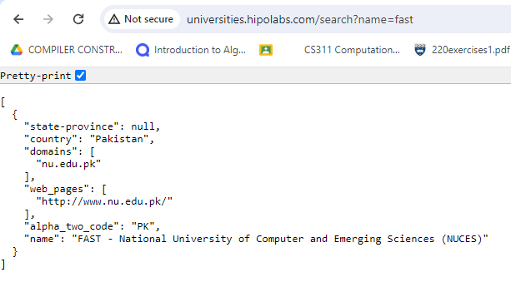
Use jquery AJAX to call the above API, and show complete university information on the HTML page.
Instructios:

- Create a simple search form with a search button.
- Apply the above API on the button click event.
- Show API response using HTML elements.

Task 02:
API URL: https://randomuser.me/api/

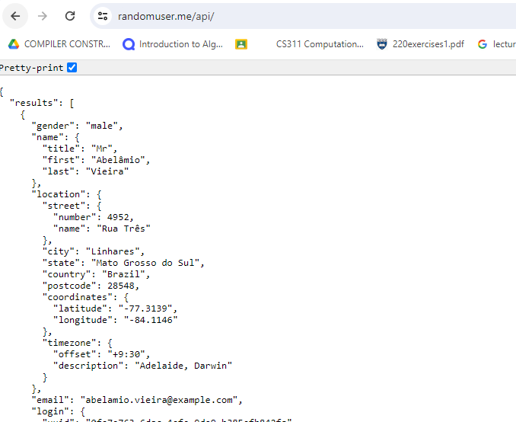

Use jQuery AJAX to call the above random user generator API, and show the complete user profile on the HTML page. (Name, profile image, location, phone, email, etc.…)

Instructios:

- Design a random user profile generator.
- Page should be responsive (mobile + desktop)
- Add CSS styles for an attractive user interface.

